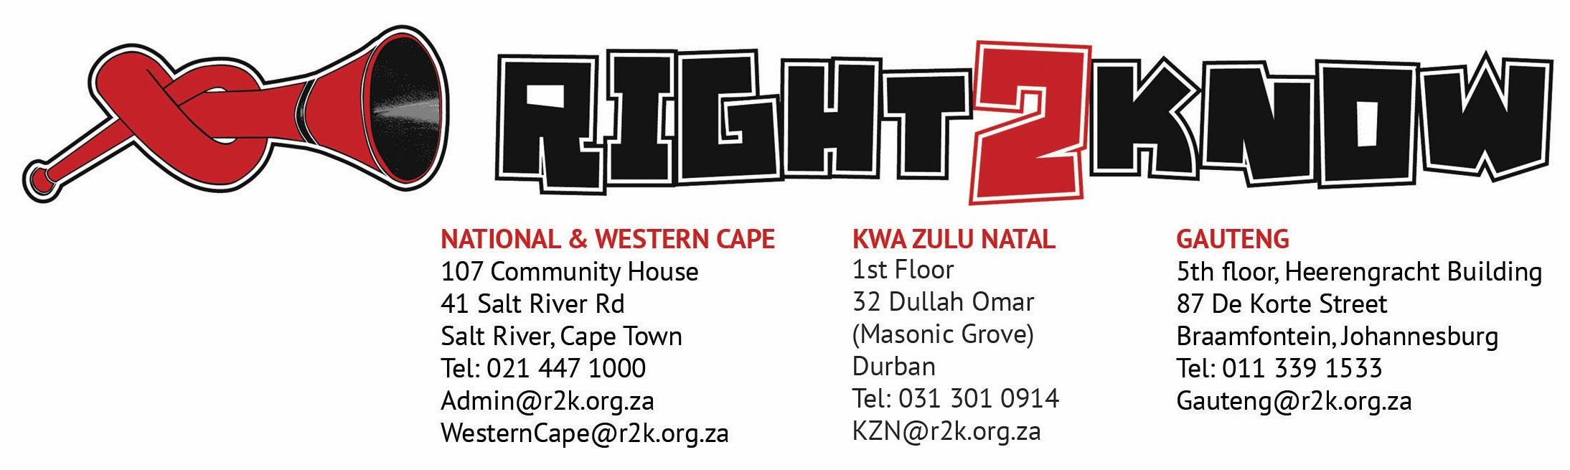
27 June 2018

R2K CELEBRATES MYVOTE COUNTS’ VICTORY IN THE CONSTITUTIONAL COURT!
R2K celebrates the judgment of the Constitutional Court which has affirmed that the Promotion of Access to Information Act (PAIA) is constitutionally deficient for failing to provide for the recording, preservation and disclosure of information on private funding of political parties and independent candidates. R2K is even more elated by the fact that the Court declared that section 32(1)(b) of the Constitution and relevant parts of PAIA can still be used to access information on private funding of political parties and independent candidates.
MyVote Counts NPC had brought an application challenging the constitutional validity of PAIA for failing to provide for the continuous and systematic recording, preservation and disclosure of information on private funding of political parties and independent candidates.
The Court recognised that unchecked or secret private funding, including from other nations, could undermine the fulfilment of constitutional obligations by political parties or independent candidates so funded, and by extension our nation’s strategic objectives.
It acknowledged that secrecy enables corruption to flourish and that a lack of transparency on private funding provides fertile and well-watered ground for corruption and/or the deception of voters. The judgment reaffirmed that access to information on the funding of political parties and independent candidates helps voters and contestants to speak against and expose corruption.
R2K is especially happy about the Court’s declaration that:
“In the interim, it is open to those seeking access to information on private funding to do so in terms of section 32(1)(b) of the Constitution or the relevant provisions of PAIA as understood within the context of this judgment. All they would have to do is state that they require information for the exercise or protection of the right to vote. For the correct position is indeed that those who require information for the exercise or protection of the right to vote, reasonable access would no doubt have to be facilitated by this judgment.”

With elections looming, this is a huge victory as this means that we can request political parties and independent candidates to provide us with information pertaining to their budgets/funds for their election campaigns.
In our submission to parliament on the political party funding Bill, we vehemently stated that: “The public has a right to know who is bankrolling the political parties and candidates that seek their votes….”
We therefore welcome this judgment as a strong statement to all political parties, independent candidates and those who fund them to desist from operating in secrecy.

For further comment contact:
Mluleki Marongo, R2K Access to Information Organiser: 062 260 0639
Alison Tilley - R2K NWG Member: 071 671 8654
Alfred Tshabalala - R2K NWG Member: 082 683 7675

ONLINE VERSION: https://bit.ly/2KpYyTI

Note to media: Please attribute contents of this statement to the Right2Know not to any individuals within R2K unless you contact a spokesperson for specific comments.

