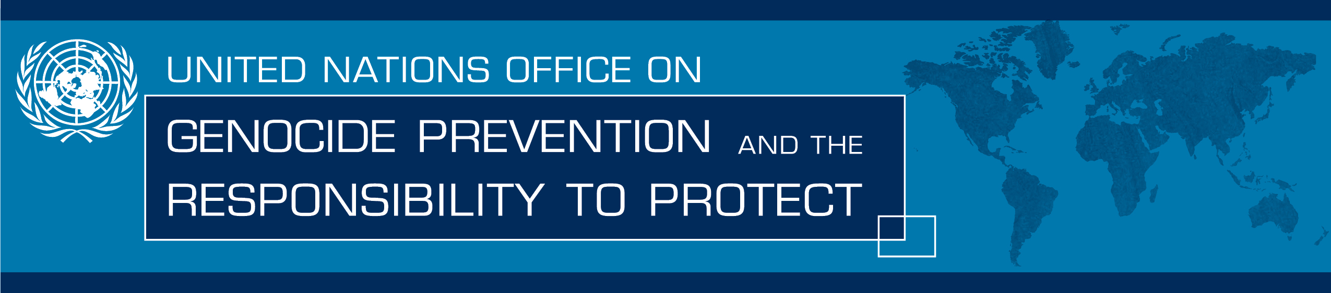
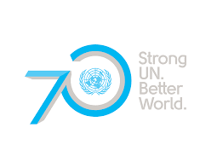

Religious Leaders from the Middle East and North Africa develop a regional strategy to prevent and counter incitement to violence that could lead to atrocity crimes
[12 November 2015] During two days of meetings in Amman, Jordan, from 11-12 November, some thirty religious leaders from the Middle East and North Africa worked together to develop a regional strategy to prevent and counter “hate speech” and incitement, in particular incitement to hatred and violence. They committed to work individually and collectively to take the strategy forward.
The meeting, which was organized by the United Nations Office on Genocide Prevention and the Responsibility to Protect, Columbia Global Centers | Middle East (Amman) and Columbia Global Freedom of Expression, built on the Plan of Action developed during a meeting of religious leaders from around the world in Fez, Morocco, in April 2015 and the Fez Declaration - which sets out principles for religious leaders to follow, particularly in situations when incitement is widespread and there is an imminent risk of violence.
The religious leaders gathered in Amman proposed, among other things, that they should:

- Establish a network of religious leaders from different religions and faiths to advise on and act to prevent and counter incidents of incitement in the region
- Increase the awareness of State authorities of the challenges and the measures that could be taken
- Invest in education, in general, and education of religious leaders, in particular
- Train religious leaders and inter-faith actors on the effective use of social media to reach a wider audience and multiply the impact of their messages
- Use intra and inter-faith dialogue to respond to acts of incitement
- Recruit and train youth ambassadors who can support and multiply initiatives through the social media
- Express solidarity with the victims of incitement to violence.

“The readiness of all religious leaders gathered here in Amman – who come from different countries and have different faiths and beliefs - to work together to deal with this challenge is truly impressive. I commend their commitment and their willingness to act, and look forward to seeing the results of this meeting,” noted Adama Dieng, United Nations Special Adviser on the Prevention of Genocide. “States are responsible for the protection of their populations, but everyone has a role to play. Given their spiritual leadership and influence, religious leaders have a special responsibility and their engagement is essential to prevent and counter incitement to violence that could lead to atrocity crimes”
“Religious leaders have clearly committed to play a fundamental role in responding, countering and preventing incitement to hatred that may lead to violence or discrimination. They have done so in recognition of the universal necessity to defend and protect believers of all faith, and non-believers; freedom of religion and equal citizenship. The discussions during these two days have highlighted the courage of those who take a stand to counter incitement to hatred, sometimes at great risks to their own lives or wellbeing. The outcome demonstrates well the importance of defending freedom of expression and increasing civic space to amplify the voices and impact of those who are at the front line in countering incitement to hatred” concluded Dr. Agnes Callamard, Director of Columbia Global Freedom of Expression.
This meeting was the second of five regional meetings to be organized with religious leaders to develop regional strategies to prevent incitement to violence. The first brought together religious leaders from Europe and took place in Treviso, Italy, in September this year.
For further information, please contact:
Simona Cruciani, United Nations Office on Genocide Prevention and the Responsibility to Protect: Cruciani@un.org

